Supporting information
Biodiversity and species competition regulate the resilience of microbial biofilm community
Supplementary Figures 1
Fig. S1 Appearance of the bioreactor (MEC) used in this study. 1
Fig. S2 Hydrogen recovery rate (A), coulombic efficiency (B) and electrical energy recovery (C) of MEC for three groups responding to pH disturbance. 2
Fig. S3 Recovery time for three groups responding to pH disturbance. 3
Fig. S4 Rarefaction curve for all samples in Group A, B and C based on sequencing data. 4
Fig. S5 Comparison of alpha diversity for Group A, B and C at different period responding to pH disturbance. 5
Fig. S6 Non-metric multidimensional scaling analysis (NMDS) with Bray-Curtis distance matrix to visualize the structure of microbial community. 6
Fig. S7 Stacked bar chart showing relative abundance of anodic microorganisms for three groups of the major phyla and dominant classes of Proteobacteria (A) and dominant genus (B). 7
Fig. S8 Overall network interactions in MEC anodic microbial community responding to pH disturbance. 8
Fig. S9 Network visualization of first neighbors and relevant interactions of dominant Geobacter in three microbial communities. 9
Supplementary Tables 10
Table S1 Difference test of recovery time between any two groups using unpaired student’s t test. 10
Table S2 Dissimilarity test for each period across three groups using MRPP, ANOSIM and PERMANOVA methods based on Bray-Curtis distance. 11
Table S3 Correlation test of recovery time to each genus with its relative abundance excluded post-disturbance period. 12
Table S4 Topological properties of the empirical phylogenetic molecular ecological networks of biofilm microbial communities of three groups in response to pH disturbance and their associated random networks. 13

Supplementary Figures
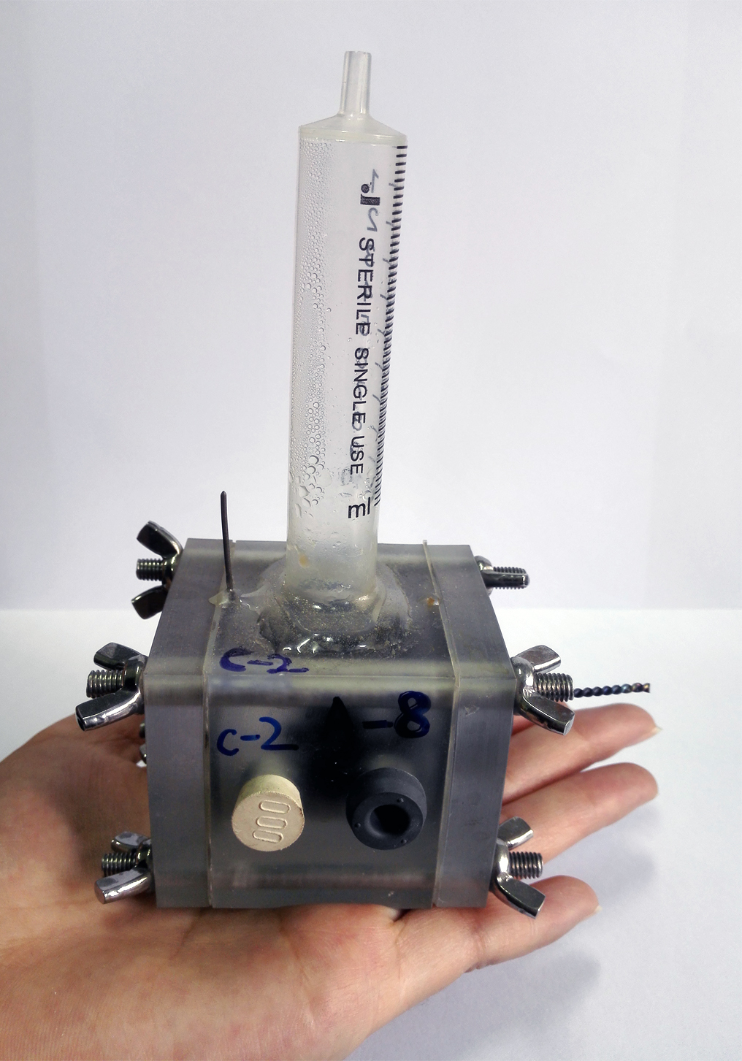
Fig. S1 Appearance of the bioreactor (MEC) used in this study.

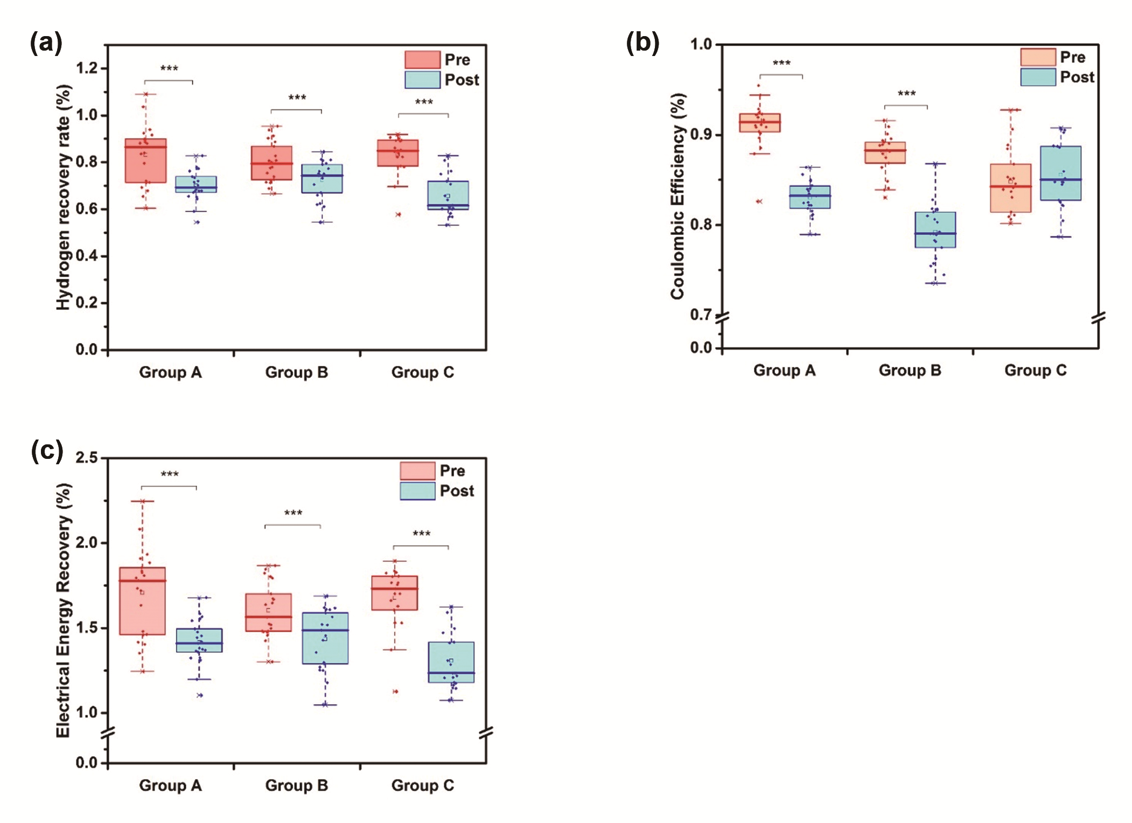
Fig. S2 Hydrogen recovery rate (A), coulombic efficiency (B) and electrical energy recovery (C) of MEC for three groups responding to pH disturbance. Pre, pre-disturbance. Post, post-disturbance (recovery period). ***, P<0.001.

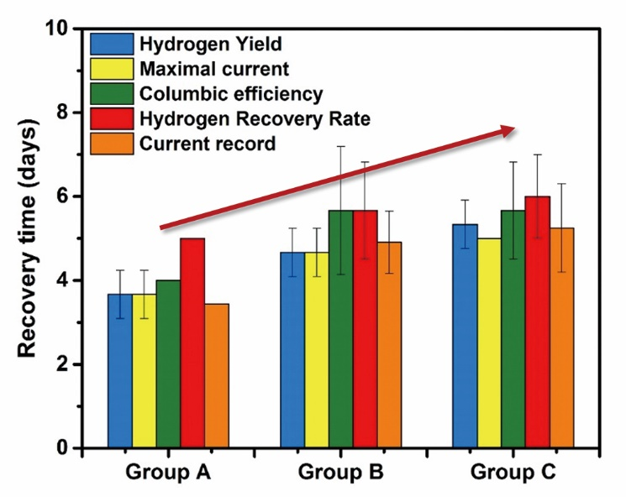
Fig. S3 Recovery time for three groups responding to pH disturbance. Five reference were selected to calculate comparably precise recovery time and the bars showed the mean value of recovery time for different reactors in same group. Error bars stands for standard deviance (S.D.).

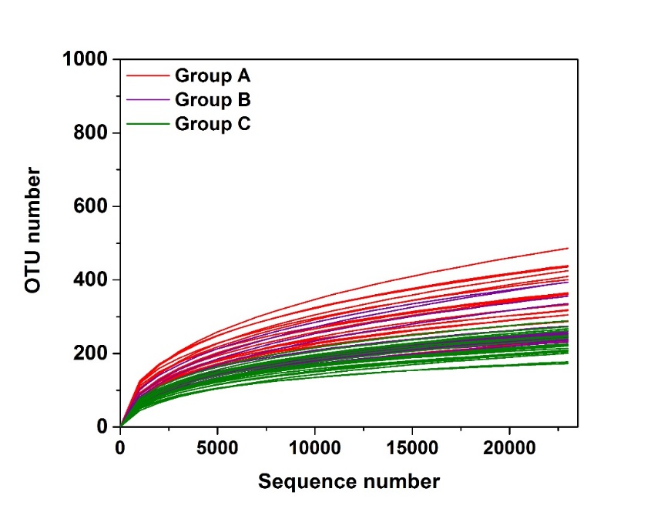
Fig. S4 Rarefaction curve for all samples in Group A, B and C based on sequencing data.

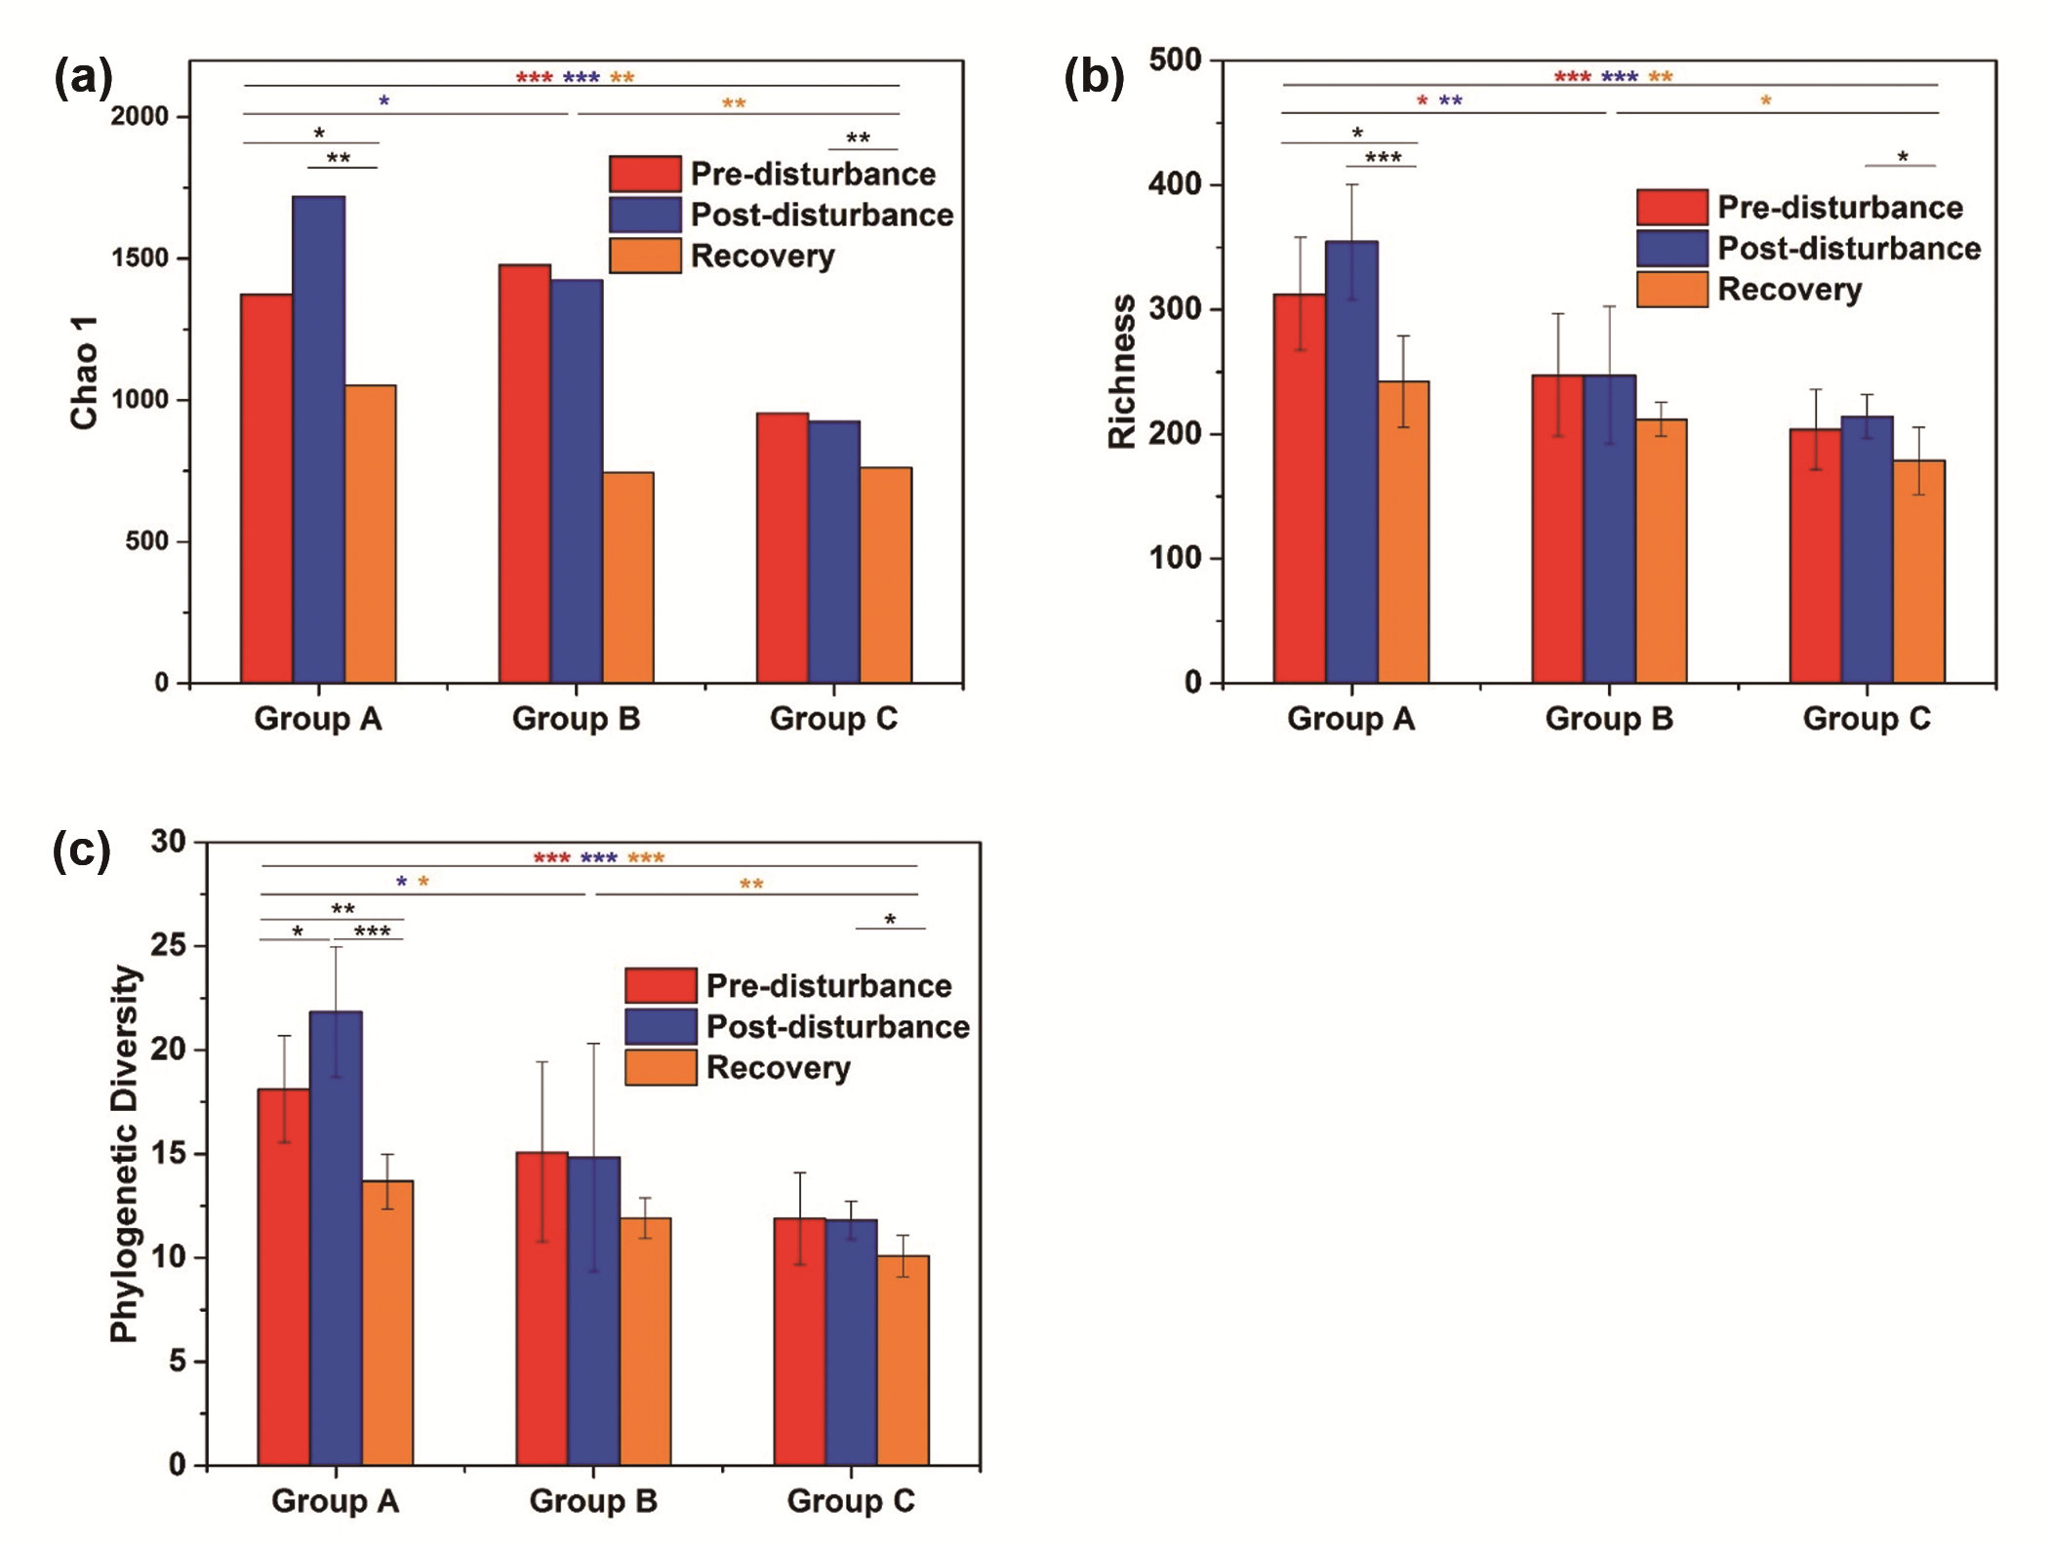
Fig. S5 Comparison of alpha diversity for Group A, B and C at different period responding to pH disturbance. (A) Estimated Chao 1 value of microbial community. (B) Observed species number (Richness) of specific samples. (C) Phylogenetic diversity.

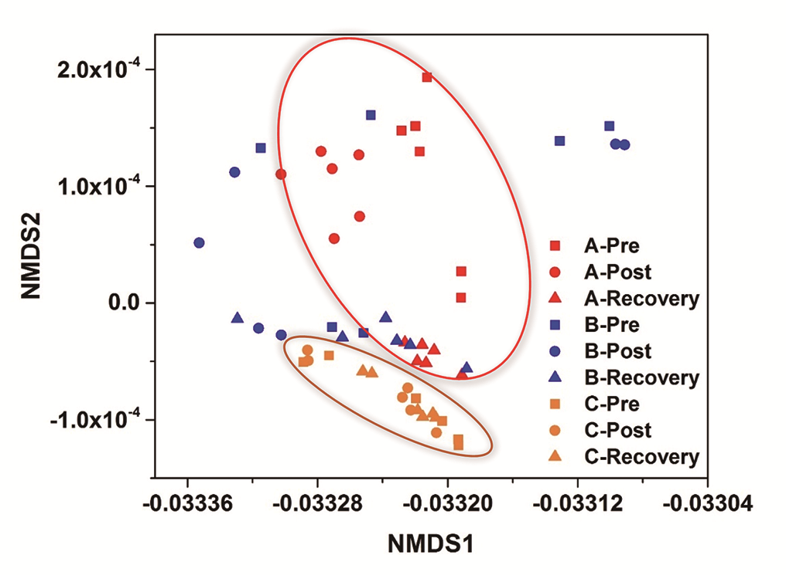
Fig. S6 Non-metric multidimensional scaling analysis (NMDS) with Bray-Curtis distance matrix to visualize the structure of microbial community across Group A (red color), Group B (blue color) and Group C (orange color). Different shapes stands for different period: pre-disturbance (), post-disturbance (), at the end of recovery ().

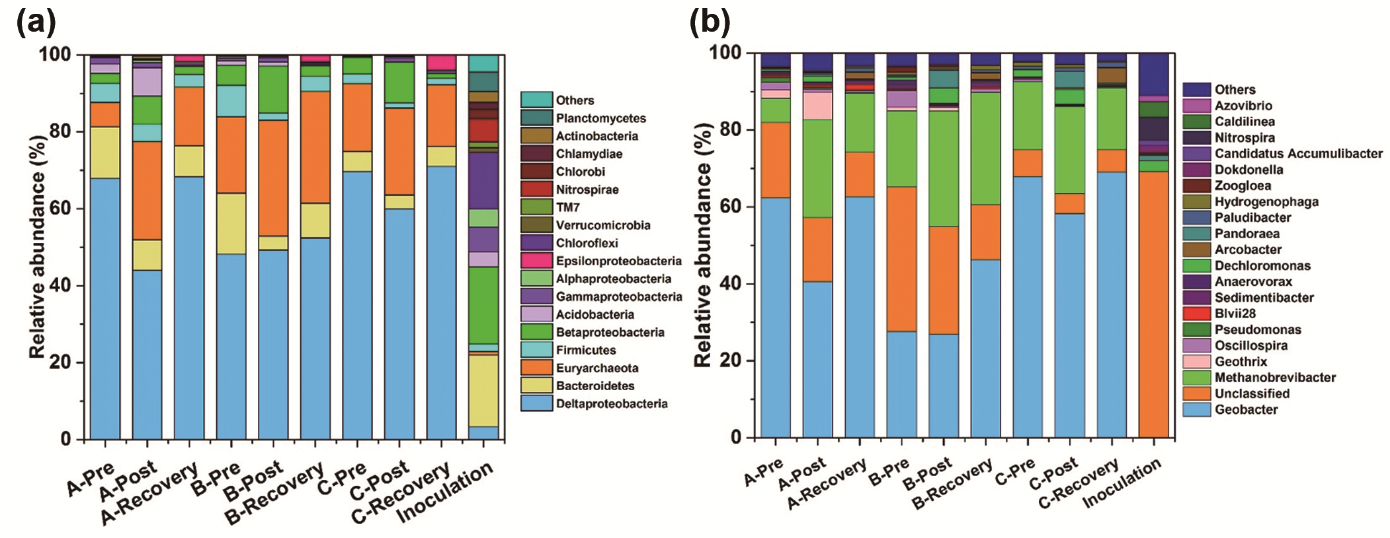
Fig. S7 Stacked bar chart showing relative abundance of anodic microorganisms for three groups of the major phyla and dominant classes of Proteobacteria (A) and dominant genus (B). Even though the top 19 genus were selected out to plot in the right stacked bar figure, the other 17 genus occupied small amounts compared to Geobacter and Methanobrevibacter.

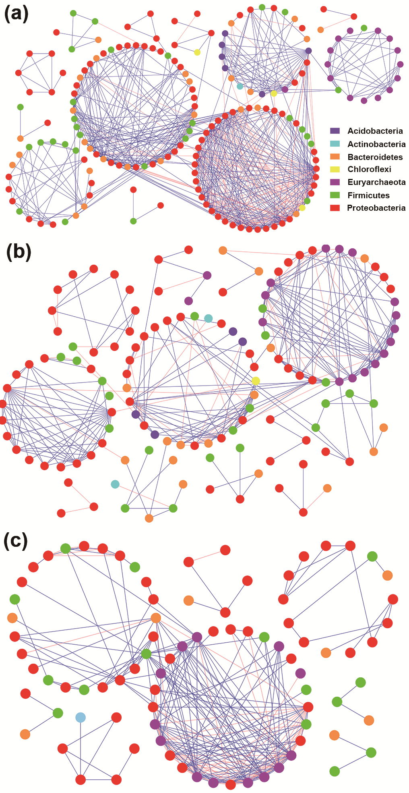
Fig. S8 Overall network interactions in MEC anodic microbial community responding to pH disturbance. Red links stand for negative interactions and blue links stand for positive interactions.

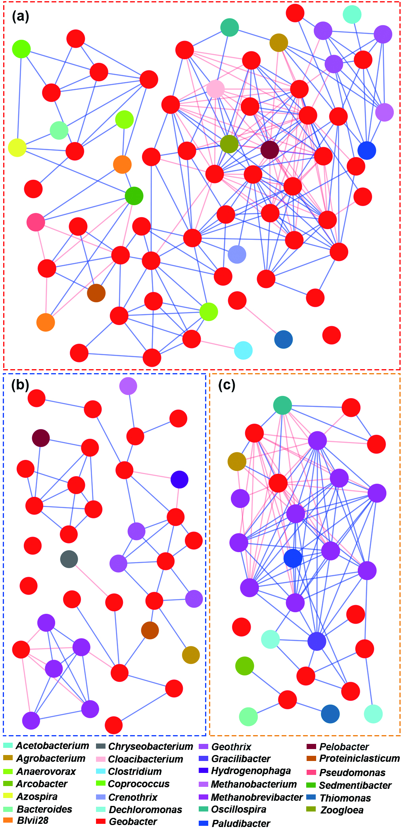
Fig. S9 Network visualization of first neighbors and relevant interactions of dominant Geobacter in three microbial communities. The node colors were corresponding to the taxonomy information at genus level. The group of Unclassified were not excluded.

Supplementary Tables
Table S1 Difference test of recovery time between any two groups using unpaired student’s t test. Five recovery time based on different selected reference were all tested. Group A and Group C showed significant difference in recovery time.
Selected reference for recovery time | P-value of Student’s t test
Hydrogen Yield |  | Group B | Group C
 | Group A | 0.101 | 0.009**
 | Group B |  | 0.117
Maximal current |  | Group B | Group C
 | Group A | 0.101 | 0.038*
 | Group B |  | 0.259
Coulombic efficiency |  | Group B | Group C
 | Group A | 0.132 | 0.027*
 | Group B |  | 0.932
Hydrogen Recovery Rate |  | Group B | Group C
 | Group A | 0.374 | 0.116
 | Group B |  | 0.670
Current record |  | Group B | Group C
 | Group A | 0.075 | 0.031*
 | Group B |  | 0.397
* Difference is significant at 0.05 level (two-tailed)
** Difference is significant at 0.01 level (two-tailed)

Table S2 Dissimilarity test for each period across three groups using MRPP, ANOSIM and PERMANOVA methods based on Bray-Curtis distance. MRPP, Multiple Response Permutation Procedure; ANOSIM, analysis of similarities; PERMANOVA, permutational multivariate analysis of variances.
 | MRPP |  | ANOSIM |  | PERMANOVA
 | Delta | P | R | P | F | P
Pre | 0.4696 | 0.001*** | 0.5938 | 0.001*** | 6.7591 | 0.001***
Post | 0.4620 | 0.001*** | 0.5733 | 0.001*** | 5.9273 | 0.001***
Recovery | 0.2613 | 0.001*** | 0.3148 | 0.001*** | 3.6889 | 0.002**
* Significance at 0.05 level; ** Significance at 0.01 level; *** Significance at 0.001 level.

Table S3 Correlation test of recovery time to each genus with its relative abundance excluded post-disturbance period. Three kinds of correlation methods were used including Pearson, Kendall and Spearman correlation methods.
Genus | Pearson |  | Kendall |  | Spearman
 | Correlation coefficient | P | tau_b | P | rho | P
Geobacter | -0.046 | 0.790 | -0.152 | 0.215 | -0.175 | 0.307
Unclassified | -0.168 | 0.328 | -0.219 | 0.073 | -0.355* | 0.034
Methanobrevibacter | 0.336* | 0.045 | 0.266* | 0.029 | 0.357* | 0.032
Geothrix | -0.428** | 0.009 | -0.430*** | 0.001 | -0.609*** | 0.000
Oscillospira | -0.091 | 0.596 | -0.042 | 0.730 | -0.071 | 0.680
Pseudomonas | -0.247 | 0.146 | -0.311* | 0.012 | -0.396* | 0.017
Blvii28 | -0.413* | 0.012 | -0.367** | 0.003 | -0.523*** | 0.001
Sedimentibacter | -0.191 | 0.266 | -0.108 | 0.378 | -0.167 | 0.331
Anaerovorax | -0.086 | 0.618 | -0.085 | 0.490 | -0.120 | 0.486
Dechloromonas | 0.155 | 0.366 | 0.148 | 0.225 | 0.225 | 0.186
Arcobacter | 0.085 | 0.622 | 0.115 | 0.348 | 0.188 | 0.272
Pandoraea | 0.090 | 0.603 | 0.206 | 0.095 | 0.282 | 0.096
Paludibacter | 0.109 | 0.527 | 0.250* | 0.041 | 0.370* | 0.026
Hydrogenophaga | 0.456** | 0.005 | 0.368** | 0.003 | 0.466** | 0.004
Zoogloea | 0.240 | 0.158 | 0.131 | 0.292 | 0.194 | 0.258
Dokdonella | -0.175 | 0.306 | -0.076 | 0.603 | -0.082 | 0.633
CandidatusAccumulibacter | -0.187 | 0.276 | -0.200 | 0.173 | -0.230 | 0.177
Nitrospira | -0.111 | 0.518 | -0.149 | 0.304 | -0.175 | 0.307
Caldilinea | -0.345* | 0.039 | -0.326* | 0.022 | -0.387* | 0.020
Azovibrio | -0.224 | 0.189 | -0.457*** | 0.001 | -0.585*** | 0.000
Others | -0.272 | 0.108 | -0.204 | 0.095 | -0.288 | 0.088
* Significant correlation at 0.05 level; ** Significant correlation at 0.01 level; *** Significant correlation at 0.001 level.

Table S4 Topological properties of the empirical phylogenetic molecular ecological networks of biofilm microbial communities of three groups in response to pH disturbance and their associated random networks.
 | Empirical networks |  |  |  |  |  |  | Random networks ª
Reactors | Similarity threshold (s_{t}) | Network size (n) | R² of power law | Average connectivity (avgK) | Average path length (GD) ^{b} | Average clustering coefficient (avgCC) | Modularity (Module No.) | Average path length (GD) | Avg. clustering coefficient (avgCC) | Modularity (Module No.)
Group A | 0.79 | 188 | 0.843 | 7.191 | 4.733 ^{c} | 0.466 ^{d} | 0.591(17) ^{e} | 2.915±0.036 | 0.103±0.010 | 0.298±0.006
Group B | 0.79 | 136 | 0.771 | 4.235 | 5.362 ^{c} | 0.310 | 0.682(14)^{e} | 3.420±0.069 | 0.055±0.013 | 0.441±0.010
Group C | 0.79 | 96 | 0.839 | 4.854 | 2.765 ^{c} | 0.312 | 0.455(13) ^{e} | 2.954±0.072 | 0.148±0.018 | 0.346±0.009
a. Random networks were generated by rewiring all nodes and links corresponding to empirical networks 100 times.
b. GD, geodesic distance.
c. Significant difference (P<0.001) in average connectivity between any two groups based on Student’s t test.
d. Significant difference (P<0.001) in average path for Group A with other two groups based on Student’s t test.
e. Significant difference (P<0.001) in modularity between any two groups based on Student’s t test.

