Fig S1. Map of the Chinese coastline indicating the sampling sites.

Fig S2. Visualization of constructed bigger zooplankton and smaller zooplankton co-occurence network. The network was colored by the zooplankton composition, and the large and small nodes represent the big and small size zooplankton species respectively. Red links represent significant positive correlations.

Fig S3. The networked species diversity and the community structure driving factors. (a) The density of the networked zooplanktonic species (bigger zooplankton, smaller zooplankton, and phytoplankton). (b) Nonmetric multidimensional scaling (NMDS) of the structure of the networked zooplanktonic communities. The clusters of the zooplankton community were confirmed by permutational multivariate analysis of variance (ADONIS), Multiple Response Permutation Procedure (MRPP), and similarity analysis (ANOSIM). (c) Canonical correspondence analysis (CCA) of the links between networked planktonic community structure and environmental drivers. (d) Variation partitioning analysis (VPA) separating the variation of community structure explained by the CCA model. (Temp: temperature). Water traits (temperature, salinity, and dissolved oxygen (DO)), artificial stresses (NO₂-N, COD, As, Pb, NH₄-N, and Zn), and distance (PCNM)

Fig S4. Robustness was measured as the proportion of taxa remained with 50% of the different trophic taxa randomly removed from each of the observed and random PZNs. Error bars correspond to the standard deviation and asterisks indicate the significance of correlation (***, P < 0.001; two-sided t test).

Fig S5. Regional PBZNs and PSZNs along the coastline. The node color indicates the planktonic taxon. Blue and red links represent significantly negative and positive correlations, respectively, and the proportion of the links type is showed by bar beside the corresponding PZN.

Fig S6. Robustness was measured as the proportion of taxa remained with 50% of the different trophic taxa randomly removed from each of regional observed and random PZNs. Error bars correspond to the standard deviation and asterisks indicate the significance of correlation (P < 0.001; two-sided t test).

Fig S7. The nodes were classified into keystone and peripheral species based on their within-module connectivity (Zi) and among-module connectivity (Pi). The red and blue mean the keystone nodes and the grey means peripheral nodes.

Fig S8. The maximum node vulnerability in most diatom (a) and dinoflagellate (c) subnetworks. Sub-networks with <20 nodes were not shown. Robustness measured as the proportion of taxa remaining with 50% of the planktonic taxa randomly removed from the subnetworks of zooplankton interact with diatoms (b) and dinoflagellates (d). Error bar corresponds to the standard deviation and sterisks represent significance of correlation (***, P < 0.001; **, P < 0.01; *, P < 0.05; two-sided t test).

Fig S9. Robustness was measured as the proportion of taxa remained with 50% of the different trophic taxa randomly removed from random diatom (a, b) and dinoflagellate (c, d) sub-networks. The P < 0.05 mean the robustness of random subnetworks was significantly different from observed subnetworks. Error bars correspond to the standard deviation and asterisks indicate the significance of correlation (***, P < 0.001; **, P < 0.01; *, P < 0.05; two-sided t test).

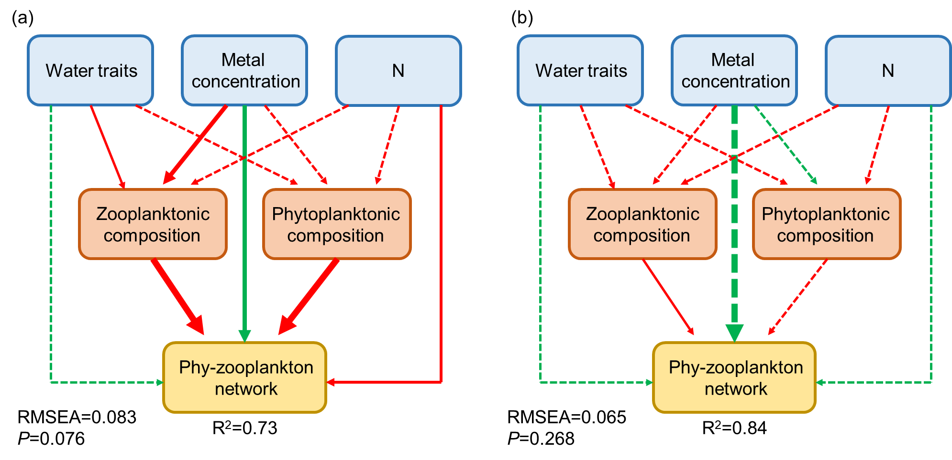
Fig S10. Structural equation model showing the paths of environmental factors and planktonic composition modeling to (a) PSZN and (b) PBZN. Solid arrows indicate significant effect sizes (P < 0.05, dashed lines P > 0.05). The green and red colors of the paths indicate negative and positive relationships, respectively. The width of the arrow represents the strength of the relationship.

Fig S11. The correlations between module eigenvalues and environmental factors within the PSZNs and PBZNs. The significance is shown by asterisk (***, P < 0.001; **, P < 0.01; *, P < 0.05)

Table S1. ANOVA of environmental factors and distance correlated with networked planktonic beta diversity. The significance is shown by number in bold.
 | F | P
PCNM2 | 2.03 | 0.059
PCNM3 | 1.71 | 0.096
PCNM4 | 1.64 | 0.154
PCNM6 | 1.49 | 0.186
PCNM8 | 2.00 | 0.140
PCNM10 | 2.24 | 0.021
PCNM11 | 2.23 | 0.129
PCNM12 | 1.92 | 0.084
PCNM14 | 3.04 | 0.001
Temperature | 6.24 | 0.001
Zn | 1.77 | 0.063
Pb | 2.07 | 0.135
As | 3.04 | 0.063
NO2N | 2.48 | 0.002
NH4N | 2.89 | 0.013
Salinity | 1.73 | 0.129
Chlorophylla | 1.08 | 0.269
COD | 1.78 | 0.081
DO | 1.82 | 0.09

Table S3. Topological properties of the PZNs with different sized zooplankton along the Chines coastline.
 |  | Network size | Links | Linkage density | Links per species
Site1 | PBZN | 20 | 16 | 2.688 | 0.8
 | PSZN | 20 | 15 | 2 | 0.75
Site2 | PBZN | 16 | 15 | 2.8 | 0.938
 | PSZN | 17 | 13 | 2.077 | 0.765
Site3 | PBZN | 81 | 231 | 9.883 | 2.852
 | PSZN | 83 | 219 | 8.480 | 2.639
Site4 | PBZN | 63 | 488 | 19.293 | 7.746
 | PSZN | 70 | 302 | 13.546 | 4.314
Site5 | PBZN | 54 | 126 | 8.437 | 2.333
 | PSZN | 58 | 141 | 8.284 | 2.431
Site6 | PBZN | 64 | 315 | 14.438 | 4.922
 | PSZN | 69 | 245 | 10.776 | 3.551
Site7 | PBZN | 155 | 980 | 23.090 | 6.323
 | PSZN | 151 | 847 | 20.955 | 5.609
Site8 | PBZN | 34 | 48 | 4.625 | 1.412
 | PSZN | 59 | 108 | 6.435 | 1.831
Site9 | PBZN | 81 | 212 | 9.434 | 2.617
 | PSZN | 82 | 220 | 8.768 | 2.683
Site10 | PBZN | 134 | 379 | 10.243 | 2.828
 | PSZN | 153 | 379 | 8.850 | 2.477
Site11 | PBZN | 118 | 328 | 8.817 | 2.779
 | PSZN | 132 | 380 | 8.184 | 2.879
Site12 | PBZN | 115 | 318 | 9.242 | 2.765
 | PSZN | 152 | 547 | 13.080 | 3.599

Table S4. Mantel tests on the significance of environmental factors and planktonic community composition. The significance is shown by numbers in bold
 | Phytoplankton |  | Smaller zooplankton |  | Bigger zooplankton
 | r | P | r | P | r | P
Temperature | 0.326 | 0.001 | 0.361 | 0.001 | 0.347 | 0.001
pH | 0.210 | 0.001 | 0.244 | 0.001 | 0.213 | 0.001
Salinity | 0.256 | 0.001 | 0.319 | 0.001 | 0.235 | 0.001
Hg | 0.003 | 0.435 | 0.113 | 0.023 | 0.130 | 0.001
Pb | 0.022 | 0.282 | 0.095 | 0.036 | 0.111 | 0.002
As | 0.019 | 0.291 | 0.118 | 0.015 | 0.138 | 0.001
Cu | 0.021 | 0.278 | 0.086 | 0.073 | 0.101 | 0.003
Zn | 0.004 | 0.445 | 0.118 | 0.019 | 0.136 | 0.001
NO₃-N | 0.250 | 0.001 | 0.290 | 0.001 | 0.205 | 0.001
NO₂-N | -0.026 | 0.727 | -0.081 | 0.954 | 0.029 | 0.175
NH₄-N | 0.053 | 0.116 | 0.021 | 0.319 | 0.077 | 0.018

